Contents

~~Install process~~ 1

Install process 2

Pull image and create network (only need to do this once) 2

Start website 2

Visit website 3

Setup process 3

Simulation process 3

Structure editor 5

Parameter sweeping 5

Additional operations 5

Reset config 5

Download or save config 5

Load from local or online config 6

Accounts 6

Configurations 6

# ~~Install process~~

~~Install wsl:~~

[~~https://docs.microsoft.com/en-us/windows/wsl/install-win10~~](https://docs.microsoft.com/en-us/windows/wsl/install-win10)

~~install anaconda:~~

~~https://www.digitalocean.com/community/tutorials/how-to-install-anaconda-on-ubuntu-18-04-quickstart~~

~~In wsl, install meep:~~

~~conda create -n mp -c conda-forge pymeep~~

~~Git fork and clone repositories:~~

|  |  |
| --- | --- |
| [~~https://github.com/u0-blip/research-webapp-front~~](https://github.com/u0-blip/research-webapp-front) | ~~npm install~~  ~~npm start~~ |
| [~~https://github.com/u0-blip/research-webapp-back~~](https://github.com/u0-blip/research-webapp-back) | ~~Pip install -r requirements.txt~~  ~~Python manager.py runserver~~ |
| [~~https://github.com/u0-blip/Summer-Research-Project~~](https://github.com/u0-blip/Summer-Research-Project) | ~~In my_meep: Pip install –user -e .~~  ~~In gen_~~ |

# Install process

## Pull image and create network (only need to do this once)

Register for docker hub. (free)

Install docker software: <https://docs.docker.com/get-docker/>

In the terminal, run

docker pull peterchen01/meep_image

docker network create redis-net

docker run --name meep_celery -w /home/research-webapp-back/ --network redis-net -it peterchen01/meep_image /bin/bash -c "service redis-server start; git pull; /root/miniconda3/bin/conda run -n mp celery -A music.celery_task.celery worker --loglevel=info"

docker run --name meep_django -w /home/research-webapp-back/ --network redis-net -p 8000:8000 -it peterchen01/meep_image /bin/bash -c "git pull; /root/miniconda3/bin/conda run -n mp python /home/research-webapp-back/manage.py runserver 0.0.0.0:8000 --insecure"

## Start website

In the command line, type:

docker start meep_celery

docker start meep_django

or in the Docker hub GUI, start the

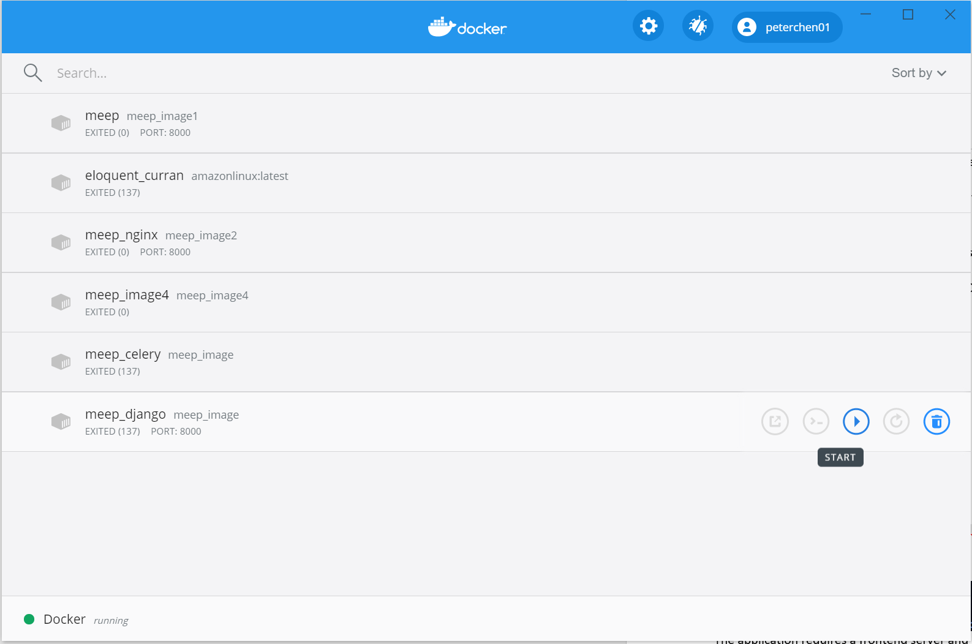

## Visit website

Go to 127.0.0.1:8000 to use the website.

# Setup process

sudo service redis-server start

python manage.py runserver

celery -A music.celery_task.celery worker --loglevel=info

The application requires a frontend server and backend server. It also requires redis server and celery task runner.

The frontend server requires the npm install.

# Simulation process

1. Understand what kind of simulation type you want to implement.
2. Use different shapes.
3. Click start in the simulation box
4. 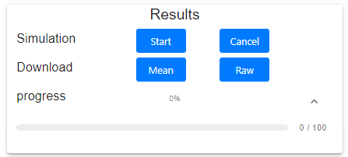
5. Once simulation is finished, the progress will reach 100%.
6. The results will be automatically updated in the plot box and the results explorer tab. The first plot is the squared value of the electrical field of the simulation results. The second plot is the structure of the simulation.
7. The view can be change via the visualization tab.
8. All the views are also available in the Results Explorer tab.
9. The result data analysis can be downloaded from the download: mean, raw of the results. Mean is the mean and standard deviation of the squared electrical field strength. Raw is the raw integrated square electrical field.

|  |  |  |
| --- | --- | --- |
| Structure | rms | Log res |
| Structure of the simulation.  Different epsilon is different shades of grey. Red line is the source. | The mean squared of the electrical field. | The logarithmic of the rms plot. |
| View only particles | video | Eps |
| View with only the matric not including the surrounding environment electrical field. | The transient view of the electrical field propagation. | The epsilon value of the structure. Similar to structure. |

# Structure editor

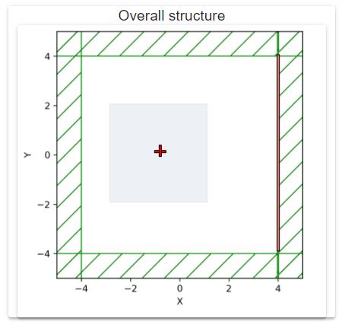

The particle and source location can be dragged. Corresponding changes will be reflected in the simulation configuration.

Note: the size of the simulation does not respond to the change in the configuration change.

It can only be used in conjunction with checker, voronoi and effective medium geometry at this moment.

# Parameter sweeping

All the parameters labelled with param, start, end, steps are sweeping parameters. This means when they are specified, their values will be converted to steps number of values, each value will be used in one particular simulation. Their results will be pooled together and returned in the form of mean and standard deviation values.

Caution that only 2 sweeping value of non 1 step values can be specified because returning none 2 dimensional mean and standard deviation matrix is not implemented.

When producing parameter sweeping, please turn off visualization. Because visualization requires resources which slows down the simulation process. And only the last frame will be displayed, which mean waste of resources.

# Additional operations

One the bottom right corner, there are 3 buttons for additional operation on the configuration.



## Reset config

The configuration is reset to a default configuration.

## Download or save config

By specifying a name in the filename, the configuration can be saved online in the owner’s account or downloaded locally.

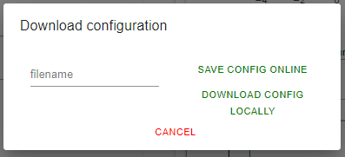

## Load from local or online config

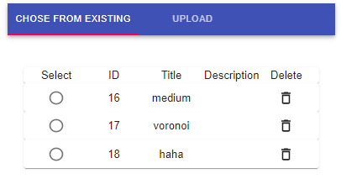

One of the saved configuration can be used to repopulate the configuration fields.

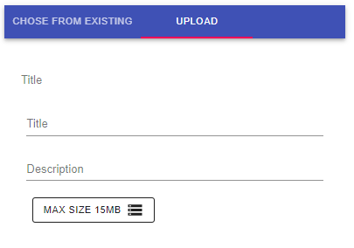

Configuration can be uploaded

## Accounts

Accounts are currently not implemented because of the limited resources came with one server. But user still have to login in order to conduct simulations.

# Configurations

Different config and their meanings.

Important config:

|  |  |  |  |
| --- | --- | --- | --- |
| Section | Name | Choice | Description |
| Simulation | sim types* | 1. Checker 2. Shape 3. Effective medium 4. Voronoi | 1. Geometry shape in certain sequence. 2. Made up by individual particles. Whose location can be specified. 3. Calculate effective medium of the rock based on the composition of the rock. 4. Generate Voronoi geometry and use it to simulate. |
| Geometry | Shape | 1. Sphere 2. Triangle 3. Hexagon 4. Cube | Different shapes that can be generated.  More complex geometry can be made up from these simple shapes. |
|  |  |  |  |

*correspond to the change of sim types, Geometry section of the configuration will change. Only the relevant configuration field will be retained. Corresponding retain field is explained below.

|  |  |  |
| --- | --- | --- |
| Choice | Retained fields | description |
| Checker | Particle area or volume | The particle size of the checker |
|  | Fill factor | The percentage of the space filled by the particles |
|  | Shape | The shape of the particles should take on |
|  |  |  |
| Shape | Particle area or volume | The particle size of the shape |
|  | Rotation | The rotation of the particles |
|  | Num particles | Number of particles included |
|  | Shape | Same as above shape |
|  | Particle locations | The location specification for each particle |
|  |  |  |
| Effective medium |  | None |
|  |  |  |
| Voronoi | Num particles vor | The number of particles for Voronoi |
|  | Rand seed | The random integer seed for random generation. |
|  |  |  |

Unimportant config:

|  |  |  |
| --- | --- | --- |
| Section | Name | Description |
| Visualization | Frame speed | The frame speeds the electrical field is played at. |
| General | Gen vor | Whether to regenerate the voronoi geometry.  If the option is not checked, the simulation will use existing voronoi geometry is one is saved automatically earlier.  If the option is checked, the server will regenerate the voronoi regardless. |
| Simulation | Change res | Whether the resolution of the simulation is automatically changed to adapt to the smaller particles. |
|  | Dimension | The dimension of the simulation |
|  | Resolution | The resolution of the simulation |
|  | Time | The time of the simulation |
|  | Start factor | The starting time to determine when the transient state finishes and the integration of the electrical field start.  It factors in the source wavelength and the size of the simulation field. |
|  | Out every | Every integration time stamp.  A value of 2 means that a snapshot of the field value is taken out every 2 simulation time units.  The longer the time stamps are, the less frequent the simulation integration is taken.  Setting this value consider the wavelength of the source. |
|  | Save every | How many out every frames to integrate is taken over.  A value of 10 means that the integration is taken over every 10 snapshots of the field values. |
| Geometry | particle size t | Whether the particles size is fixed or following a gaussian distribution |
|  | Solid center | The center of the simulation solid |
|  | Solid size | The size |
|  | Cell size | The size of the simulation cell |
|  | Eps value | The epsilon values that can be assigned to the component parts. |
|  | Component | The component eps values.  When the sim types is checker or voronoi, the components can be increased. This means that the more component can be randomly assigned to the different particles in checker or voronoi. |
|  | Pm thick | The thickness of the pml layer. |
| Source | Mode | The mode of the source.   1. Normal: normal plane wave. 2. Gaussian: wave with Gaussian strength profile. |
|  | Size | The size of the source. |
|  | Center | The center location |
|  | Fcen | The frequency of the wave, in units of GHz. |
|  | Titl angle | If the wave is in Gaussian mode, the tilt of the source beam. |
|  | Sigma | The spreadness of the source beam. |
|  | Amp | The amplitude of the wave. |
|  | Fwidth | The focusness of the beam in the frequency domain. |